Supplementary Information
Physics-Aware Lightweight Segmentation for Quantitative Holographic Cell Analysis with Optical Mass Preservation
Usama Ikram¹, Youhyun Kim², and Inkyu Moon^{1,2,*}
¹Department of Artificial Intelligence, DGIST, Daegu 42988, South Korea
²Department of Robotics & Mechatronics Engineering, DGIST, Daegu 42988, South Korea

*Corresponding author: inkyu.moon@dgist.ac.kr (I. Moon)

S-I. Low-Rank Adaptation (LoRA) Rank Ablation for EdgeSAM
The effect of LoRA rank was evaluated for EdgeSAM using r = 2, 4, 8, 16 and 32. Table S-1 reports segmentation quality (Dice, AJI and boundary F1), the physics-related integrated-phase error (IPE) and the number of trainable parameters for each rank, as means over three training seeds (42, 43, and 44). The dependence on rank was not monotonic. Rank 32 gave the highest Dice (0.738), AJI (0.335) and boundary F1 (0.642) and the lowest IPE (3.02%) of the five ranks, and EdgeSAM at r = 32 is used as the primary configuration in the main text. At r = 8, Dice, AJI, boundary F1 and IPE were 0.647, 0.249, 0.608 and 3.81%, respectively; r = 4 gave a lower IPE (3.48%) than r = 8 and r = 16 (4.66%). The higher segmentation quality at r = 32 comes with a larger adaptation parameter set (1.47 M trainable parameters versus 0.53 M at r = 8). Inference latency and peak VRAM were measured only for the rank-8 model (Table 6 of the main text); no rank-specific latency or memory data are available, and no statement is made here on how computational cost changes with rank. MobileSAM at r = 8 is retained as the sensitivity configuration in the main text.
TABLE S-1
LoRA rank ablation for EdgeSAM. Values are means over three training seeds (42, 43, and 44). The shaded row indicates the primary configuration (r = 32). Dice, AJI and boundary F1 describe segmentation quality; IPE is the global integrated-phase error. The number of trainable parameters (and its percentage of all parameters) is given for each rank. Mean IoU is not reported for this sweep. Latency and peak VRAM were measured only at r = 8 (Table 6 of the main text) and are therefore not listed here.
Rank (r) | Trainable | Mean Dice ↑ | AJI ↑ | Boundary F1 ↑ | IPE (%) ↓
2 | 0.30M (5.20%) | 0.625 | 0.249 | 0.598 | 4.45
4 | 0.38M (6.46%) | 0.703 | 0.252 | 0.615 | 3.48
8 | 0.53M (8.90%) | 0.647 | 0.249 | 0.608 | 3.81
16 | 0.85M (13.40%) | 0.665 | 0.277 | 0.623 | 4.66
32 | 1.47M (21.19%) | 0.738 | 0.335 | 0.642 | 3.02
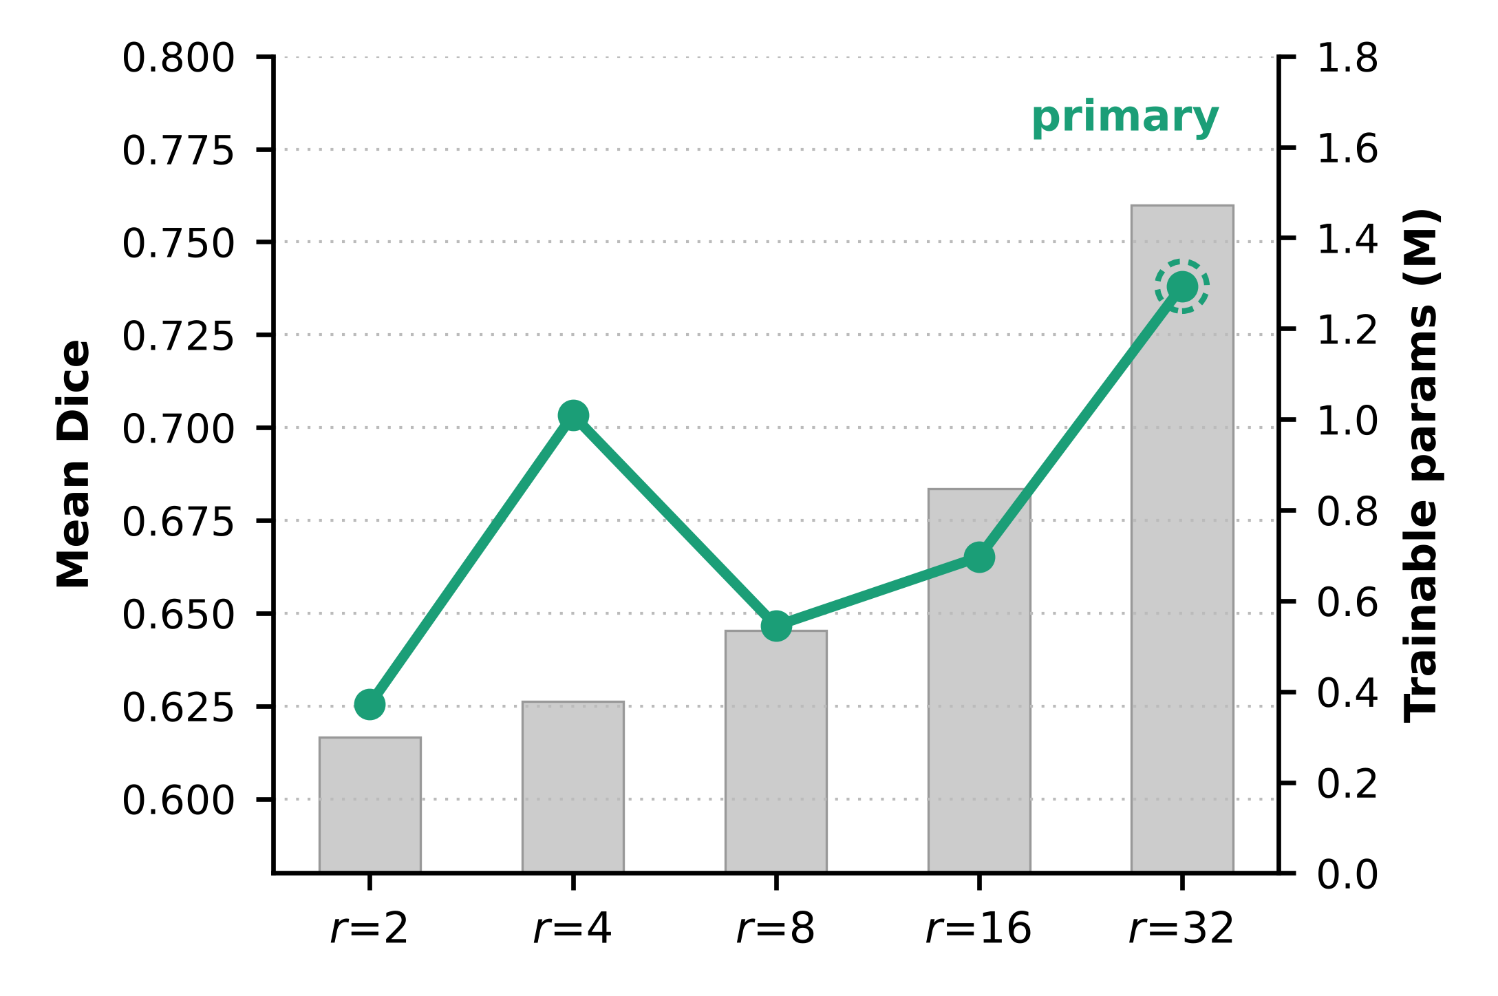
Fig. S-1. Effect of LoRA rank on EdgeSAM mean Dice (line; mean of three training seeds) and trainable parameters (bars). The primary configuration (r = 32) is marked.
S-II. Accuracy-Efficiency Trade-off
Fig. S-2 summarizes five quantities at LoRA rank 8: mean Dice, AJI and boundary F1 (three-seed means), FP32 forward-pass throughput (the higher of the two runtimes, averaged over three timing passes), and memory efficiency (the reciprocal of the PyTorch FP32 baseline-subtracted GPU-memory footprint). Each axis is divided by the best of the three architectures: Dice 0.810, AJI 0.551, boundary F1 0.814, throughput 396.5 FPS, and memory 42 MB. The axes mix segmentation and efficiency measures, so the polygon area is not an overall score and the radar does not identify a single best architecture. The favorable AJI, boundary-F1 and throughput values of MobileNet-UNet must be read together with its class-loss failure: two of four annotated classes were lost in all three seeds. The radar does not encode per-class coverage; class-level results are shown in Fig. 3 of the main text.
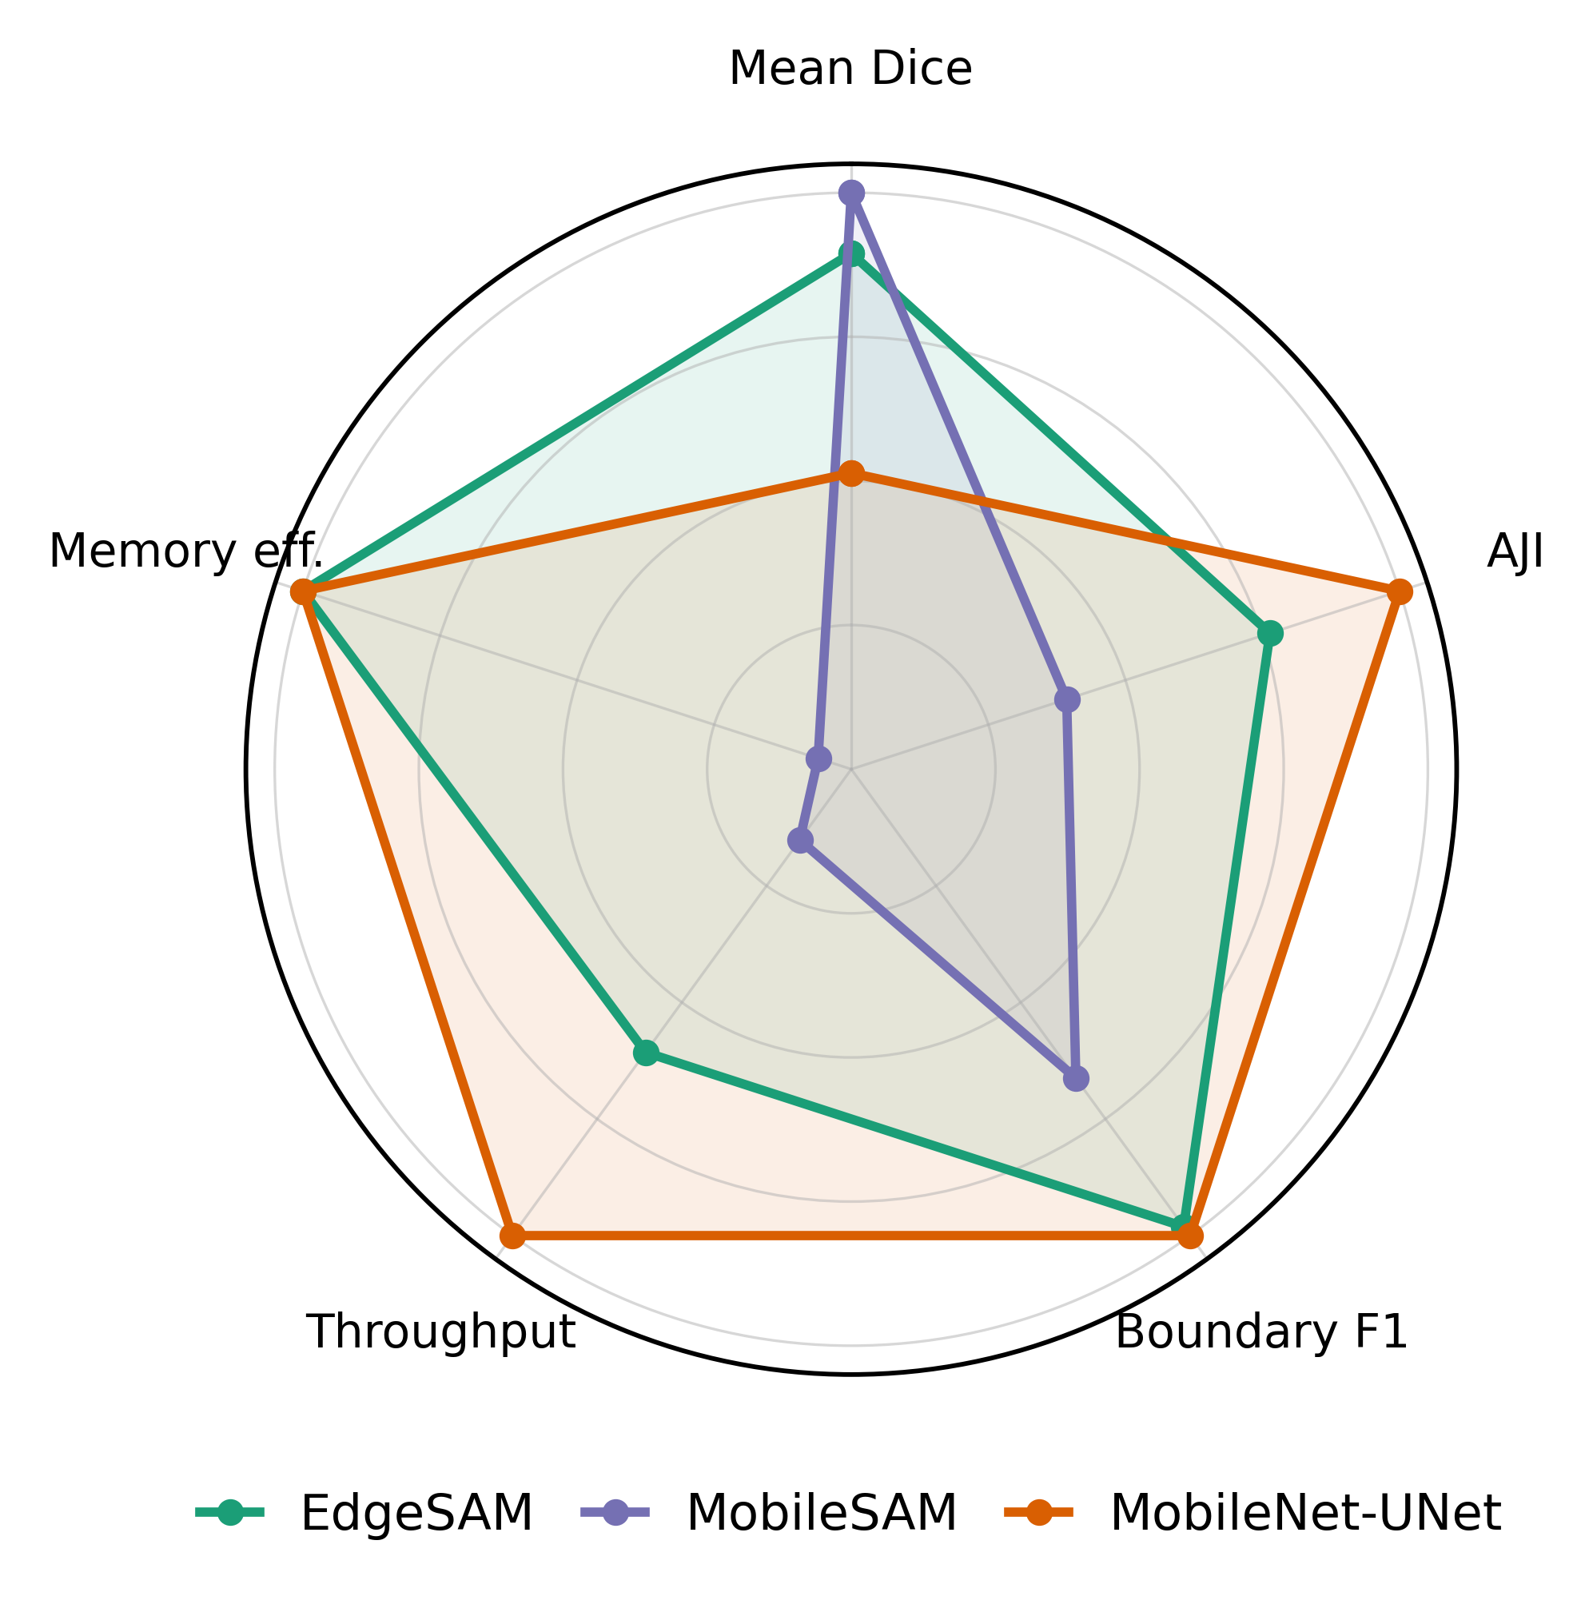
Fig. S-2. Aggregate comparison of the three architectures at LoRA rank r = 8. Mean Dice, AJI and boundary F1 are means over three independently trained seeds (42, 43, 44) of the full objective. Throughput is the higher of the two runtimes’ FP32 forward-pass throughputs for each architecture, averaged over three timing passes (ONNX Runtime for EdgeSAM and MobileNet-UNet, PyTorch for MobileSAM). Memory efficiency is the reciprocal of the PyTorch FP32 baseline-subtracted GPU-memory footprint (Table 6). Each axis is divided by the best value among the three architectures, so 1 marks the best architecture on that axis (Dice 0.810, AJI 0.551, boundary F1 0.814, throughput 396.5 FPS, memory 42 MB). The enclosed polygon area is not an overall score and does not rank the architectures. The radar does not encode per-class coverage: MobileNet-UNet lost the classes of spherocytes and stomatocytes (mask values 2 and 4) in all three seeds, and EdgeSAM lost the spherocyte class (mask value 2) in one seed (seed 44). A class was counted as lost when its per-class Dice was below 0.05; this threshold applies to per-class Dice, not to overall model Dice.
Fig. S-3 relates segmentation accuracy to FP32 forward-pass throughput at LoRA rank 8. Throughput ranges are given across the three timing passes for each runtime separately. EdgeSAM ran at 81.3–102.8 FPS with PyTorch and 229.1–277.0 FPS with ONNX Runtime; its Dice was 0.647 ± 0.114 over three training seeds, and one of the three seeds lost a class. MobileSAM ran at 48.8–49.5 FPS with PyTorch and 39.1–39.7 FPS with ONNX Runtime, so ONNX Runtime did not accelerate it; its Dice was 0.810 ± 0.006, with no class loss in any of the three seeds. MobileNet-UNet ran at 174.7–180.4 FPS with PyTorch and 373.7–431.0 FPS with ONNX Runtime; its Dice was 0.412 ± 0.004, and two of the four annotated classes were lost in all three seeds. Dice was evaluated with the PyTorch checkpoints and is therefore the same for both runtimes of an architecture. Only rank 8 was timed.

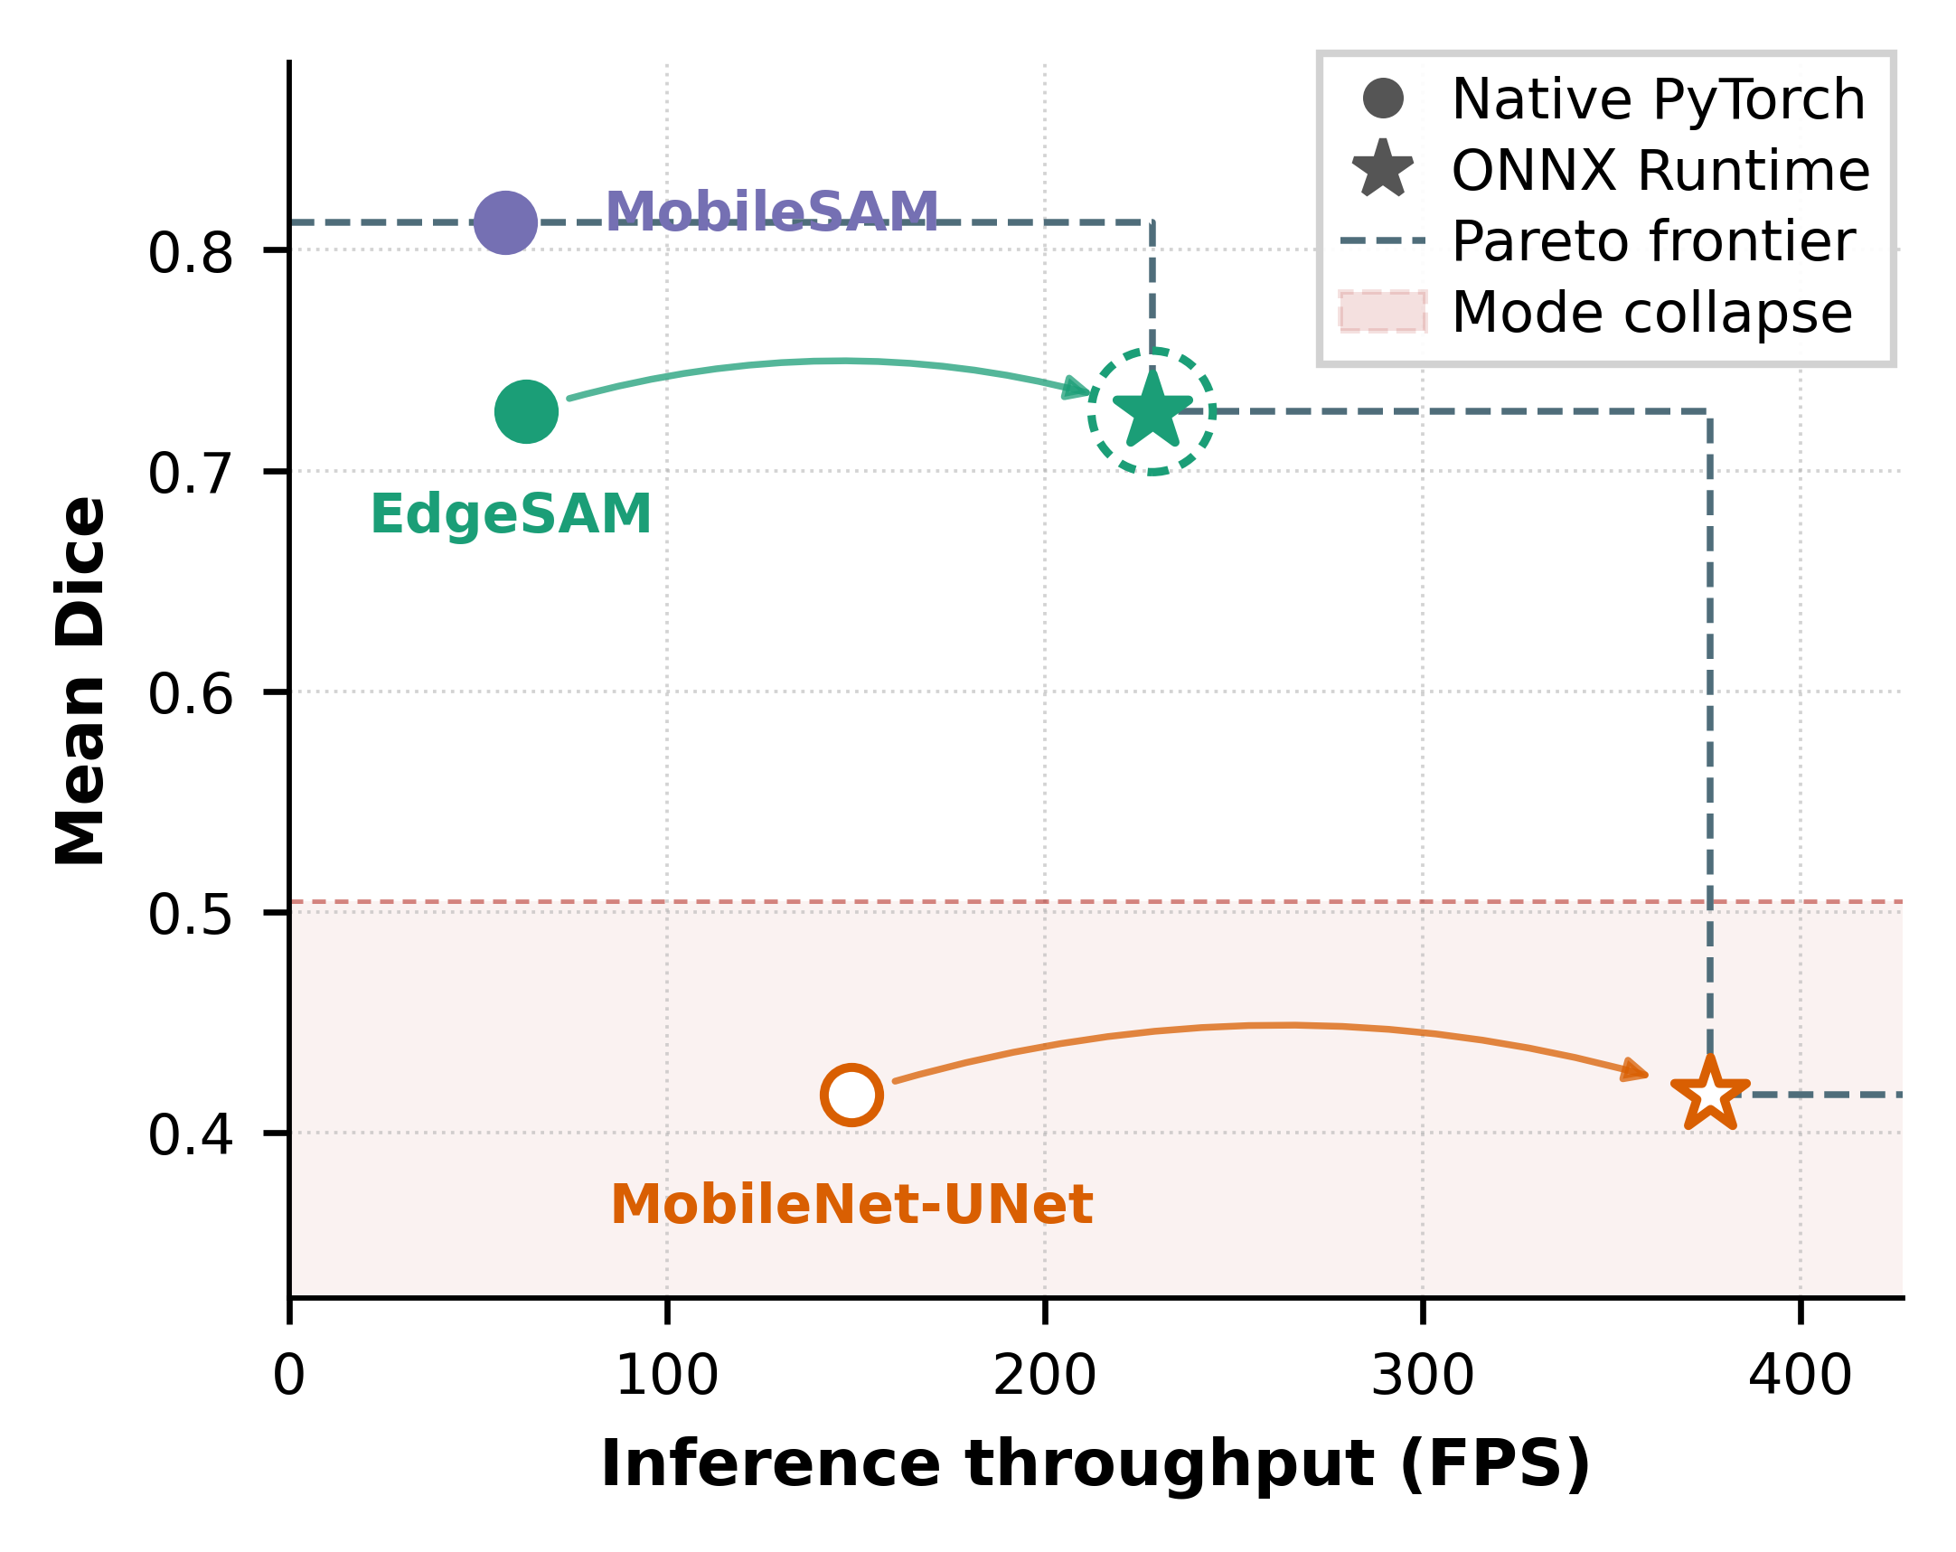
Fig. S-3. Mean Dice at LoRA rank r = 8 versus FP32 forward-pass throughput. Vertical position: Dice of the full objective, averaged over three independently trained seeds (42, 43, 44); error bars show the SD across these seeds (n = 3). Horizontal position: FP32 forward-pass throughput averaged over three timing passes of the rank-8 checkpoints; these timing passes are not training seeds, and no throughput error bars are shown. Circles denote native PyTorch and squares denote ONNX Runtime; an arrow joins the two runtimes of each architecture. Dice was evaluated using the PyTorch checkpoints and is therefore plotted at the same value for both runtimes. Class loss is not marked in the figure. MobileNet-UNet lost the classes of spherocytes and stomatocytes (mask values 2 and 4) in all three seeds. EdgeSAM lost the spherocyte class (mask value 2) in one seed (seed 44; overall Dice 0.515 for that seed). A class was counted as lost when its per-class Dice was below 0.05; this threshold applies to per-class Dice, not to overall model Dice.
S-III. Boundary Quality and Physical Gradient Alignment
Accurate boundary localization is particularly important in quantitative phase imaging (QPI) because dilation or erosion of the predicted cellular region directly affects the integrated phase used for subsequent quantitative analysis. The boundary-gradient alignment (BGA) term addresses this issue by encouraging predicted cell boundaries to follow spatial phase transitions in the quantitative phase map. As illustrated in Fig. S-4, EdgeSAM predictions show clear spatial correspondence with strong phase-gradient structures near cellular boundaries. The contribution of BGA is further supported by the loss ablation in Section 4.3 of the main text, where adding BGA to the phase-mask contrast (PMC) configuration removed the lost classes and raised the mean Dice (EdgeSAM at r = 8: 0.672 to 0.735; at r = 32: 0.680 to 0.746), while the boundary F1 changed little (0.621 to 0.628 at r = 8; 0.638 to 0.643 at r = 32). Moreover, as summarized in Table S-1, the boundary F1 of EdgeSAM ranged from 0.598 to 0.642 across the rank sweep, with the highest value at r = 32 (0.642) and the lowest at r = 2 (0.598). Together, these results are consistent with phase-gradient information acting as a physical cue for cellular boundary localization.
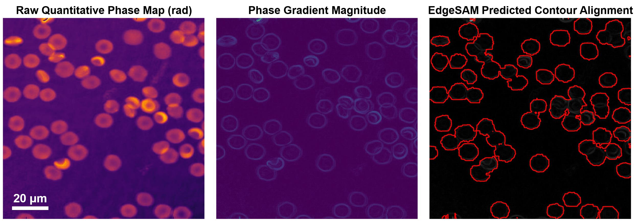
Fig. S-4. Alignment of predicted cell contours with quantitative phase gradients. Left: quantitative phase map. Center: phase-gradient magnitude. Right: EdgeSAM (r = 8) contours overlaid on the phase-gradient map, showing their spatial correspondence with phase-gradient structures.
S-IV. Representative Quantitative Phase Images over the Storage Period
Fig. S-5 shows representative quantitative phase images from different points of the 47-day storage period. Cells at the earliest time point are mostly biconcave discocytes, while images from later storage show a growing share of cells with altered shapes.

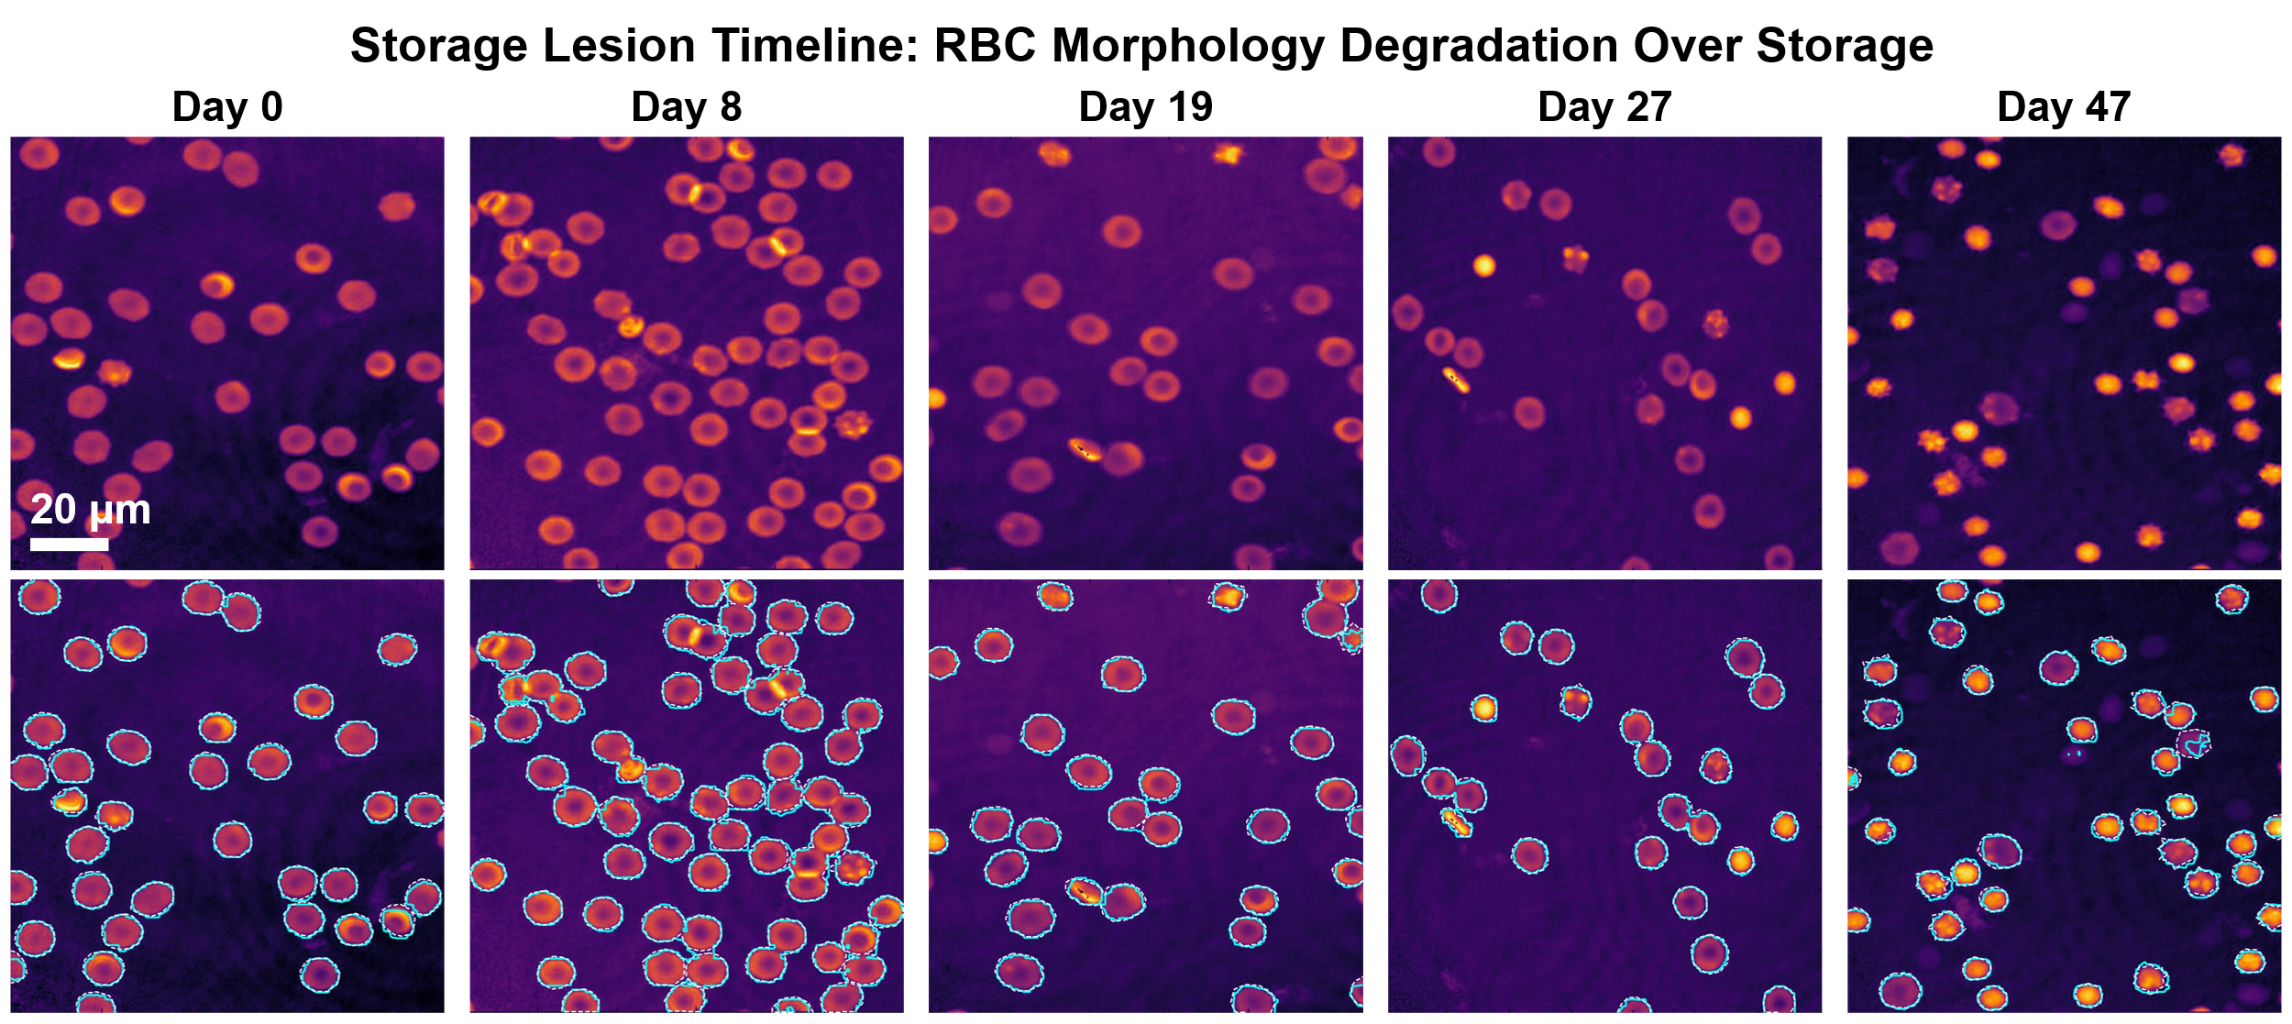
Fig. S-5. Representative quantitative phase images illustrating RBC morphological changes associated with storage lesion over the 47-day storage period.
S-V. Loss Ablation at All LoRA Ranks
Table S-2 reports the component-wise ablation of the physics-aware loss (Dice only, Dice with PMC, Dice with PMC and BGA, and the full objective incorporating IPP) for the three architectures at every LoRA rank (r = 2, 4, 8, 16, and 32), as means over three training seeds (42, 43, and 44). Over the 45 paired comparisons (three architectures, five ranks, three seeds), the full objective gave a lower global IPE than Dice alone in 42 (EdgeSAM 15 of 15, MobileSAM 14 of 15, MobileNet-UNet 13 of 15) and a lower global IPE than Dice with PMC and BGA in 36 (EdgeSAM 10, MobileSAM 13, MobileNet-UNet 13). These counts do not separate the effect of the objective from training instability: the Dice-only configuration lost a class in 6 of 15 EdgeSAM runs, 3 of 15 MobileSAM runs, and 13 of 15 MobileNet-UNet runs, and the full objective in 3, 1, and 15 runs, respectively. For EdgeSAM, the AJI with the full objective was not higher than with Dice and PMC and BGA in any of the 15 comparisons, and the Dice was higher with the full objective than with Dice alone in 9 of 15 EdgeSAM comparisons.
TABLE S-2 Loss ablation at all LoRA ranks. Values are means over three training seeds (42, 43, and 44). D, Dice only; P, Dice with PMC; B, Dice with PMC and BGA; F, full objective incorporating IPP. IPE is the global Integrated-Phase Error (%, lower is better). The last column gives the number of seeds in which a class was lost (Dice < 0.05) for the D, P, B, and F configurations; means that include such a seed are lowered accordingly. The primary configuration is EdgeSAM at r = 32, and MobileSAM at r = 8 is the sensitivity comparison.
Architecture | Rank | Dice (D) | Dice (P) | Dice (B) | Dice (F) | IPE % (D) | IPE % (P) | IPE % (B) | IPE % (F) | Seeds with a lost class (D / P / B / F)
EdgeSAM | 2 | 0.576 | 0.710 | 0.717 | 0.625 | 14.42 | 5.26 | 4.88 | 4.45 | 0 / 0 / 0 / 1
 | 4 | 0.610 | 0.727 | 0.723 | 0.703 | 10.96 | 4.68 | 4.98 | 3.48 | 1 / 0 / 0 / 0
 | 8 | 0.624 | 0.672 | 0.735 | 0.647 | 10.82 | 7.97 | 4.25 | 3.81 | 1 / 1 / 0 / 1
 | 16 | 0.621 | 0.741 | 0.742 | 0.665 | 11.05 | 3.71 | 3.43 | 4.66 | 2 / 0 / 0 / 1
 | 32 | 0.619 | 0.680 | 0.746 | 0.738 | 11.20 | 7.45 | 3.64 | 3.02 | 2 / 1 / 0 / 0
MobileSAM | 2 | 0.741 | 0.805 | 0.740 | 0.808 | 5.35 | 1.55 | 5.32 | 1.30 | 1 / 0 / 1 / 0
 | 4 | 0.811 | 0.806 | 0.741 | 0.811 | 1.44 | 1.50 | 5.23 | 1.34 | 0 / 0 / 1 / 0
 | 8 | 0.811 | 0.813 | 0.813 | 0.810 | 1.53 | 1.60 | 1.48 | 1.32 | 0 / 0 / 0 / 0
 | 16 | 0.813 | 0.813 | 0.817 | 0.813 | 1.54 | 1.58 | 1.55 | 1.29 | 0 / 0 / 0 / 0
 | 32 | 0.674 | 0.817 | 0.818 | 0.687 | 9.23 | 1.58 | 1.46 | 1.76 | 2 / 0 / 0 / 1
MobileNet-UNet | 2 | 0.416 | 0.413 | 0.549 | 0.410 | 17.98 | 19.88 | 12.40 | 2.61 | 3 / 3 / 3 / 3
 | 4 | 0.482 | 0.417 | 0.490 | 0.406 | 16.52 | 19.39 | 14.70 | 2.50 | 3 / 3 / 3 / 3
 | 8 | 0.485 | 0.414 | 0.544 | 0.412 | 15.48 | 19.79 | 13.96 | 2.60 | 2 / 3 / 2 / 3
 | 16 | 0.550 | 0.413 | 0.612 | 0.414 | 14.18 | 20.13 | 11.50 | 3.09 | 2 / 3 / 2 / 3
 | 32 | 0.359 | 0.486 | 0.418 | 0.476 | 20.83 | 15.96 | 19.54 | 5.83 | 3 / 3 / 3 / 3

S-VI. Storage-Period Analysis: Component Counts, Sensitivity Analysis and Per-Seed Data
This section supports Section 4.8 of the main text. Cells are never pooled across training seeds; the annotation is seed-independent. Per-seed values behind Table 7 and Table S-3 are given in Supplementary data S-Z (Section S-VII).
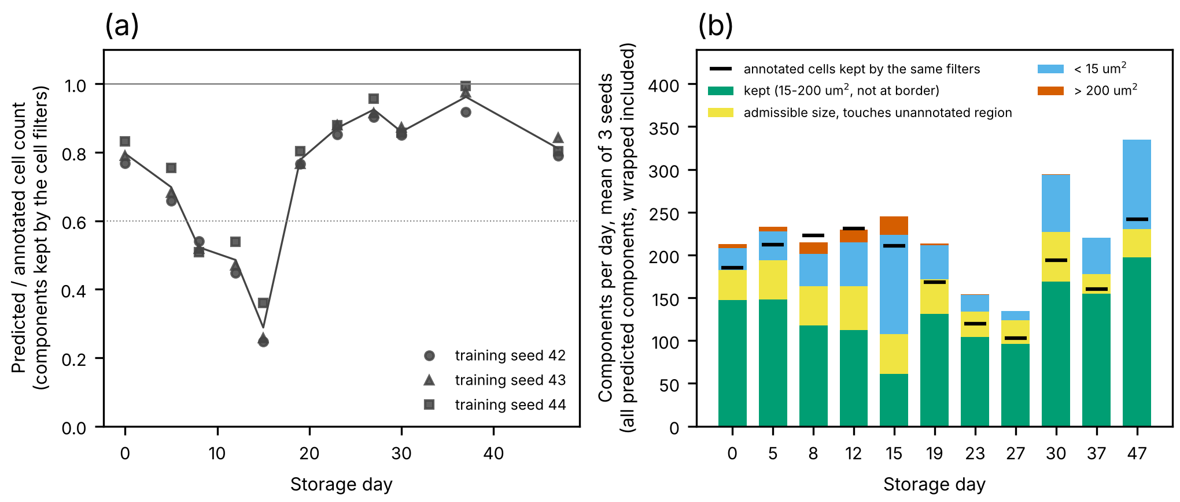
Fig. S-6. Why predicted cell counts are low on crowded days (EdgeSAM r32, three training seeds). (a) Kept predicted components divided by annotated cells per storage day (wrapping-excluded; markers: seeds; line: seed mean; dotted: 0.6). (b) Fate of all predicted components per day (mean of three seeds, wrapped components included): kept (15-200 µm², not touching an unannotated region), admissible size but touching an unannotated region, smaller than 15 µm², larger than 200 µm²; black bars: annotated cells kept by the same filters. Cells are 4-connected components of the class-agnostic foreground, so touching cells merge. On day 15 the six images give on average 61.3 kept components (mean of three seeds) for 211 annotated cells (all components, wrapped components included; after exclusion of wrapped cells there are 51, 53 and 74 kept components for 206 annotated cells), with 116 fragments below 15 µm², 22 components above 200 µm² and 46 otherwise admissible components touching the unannotated region; predicted foreground area is 0.98 of the annotated area. The counts therefore reflect the component definition in crowded images and are not cell counts. The analysis was performed for EdgeSAM r32 only.
TABLE S-3
Sensitivity analysis with MobileSAM LoRA r8 (training seeds 42, 43, 44): storage-period measurements in the 66 validation images, in the layout and with the notation of Table 7 (footnotes a to f of Table 7 apply unchanged). Wrapped cells are excluded; the annotation is the same as in Table 7 (1,988 cells). Kept components were 1,328, 1,313 and 1,337 for seeds 42, 43 and 44 and are not cell counts. Agreement with the annotation (mean ± SD over seeds): MdARE 2.9 ± 0.2%, Pearson r = 0.24 ± 0.10, CCC = 0.21 ± 0.11. Between early and late storage the median area changed by −40.6 ± 1.3% and the median dry mass by −2.6 ± 0.4%. Date-clustered permutation p-values: area 0.005, 0.006, 0.026 (the bootstrap interval of seed 44, −0.81 to +0.05, includes zero); dry mass 0.35, 0.24, 0.34 (all intervals include zero). Absolute dry mass was not independently validated.
Storage day | Annotation: cells (N) | Annotation: area, µm², mean (cell-level SD) | Annotation: dry mass, pg, mean (cell-level SD) | MobileSAM r8: components kept, seeds 42 / 43 / 44 | MobileSAM r8: kept components / annotated cells, mean over seeds | MobileSAM r8: area, µm², mean of per-seed day means [seed min-max] (cell-level SD, mean over seeds) | MobileSAM r8: dry mass, pg, mean of per-seed day means [seed min-max] (cell-level SD, mean over seeds)
0 | 185 | 52.1 (21.6) | 31.7 (14.3) | 138 / 138 / 140 | 0.75 | 52.5 [52.0-53.3] (24.7) | 33.2 [32.9-33.8] (15.4)
5 | 211 | 51.2 (21.9) | 33.2 (15.0) | 142 / 150 / 145 | 0.69 | 57.1 [56.1-58.4] (28.9) | 37.7 [37.2-38.5] (19.2)
8 | 220 | 51.9 (24.4) | 34.9 (17.8) | 104 / 105 / 107 | 0.48 LOW | 55.3 [54.8-55.8] (27.6) | 37.3 [36.9-37.6] (18.0)
12 | 230 | 54.9 (31.8) | 36.3 (22.3) | 105 / 104 / 106 | 0.46 LOW | 59.7 [58.4-61.0] (35.7) | 39.7 [39.0-40.6] (23.6)
15 | 206 | 59.3 (32.6) | 40.9 (25.1) | 34 / 32 / 40 | 0.17 LOW | 56.8 [51.2-62.7] (30.7) | 39.1 [35.7-42.8] (20.1)
19 | 162 | 49.8 (23.7) | 32.2 (15.6) | 127 / 127 / 130 | 0.79 | 52.2 [51.0-54.0] (27.2) | 34.7 [34.0-35.5] (17.1)
23 | 108 | 49.5 (20.3) | 30.6 (12.4) | 89 / 91 / 93 | 0.84 | 50.4 [49.4-51.6] (20.0) | 31.7 [31.3-32.1] (12.7)
27 | 93 | 50.8 (22.9) | 33.0 (13.3) | 81 / 81 / 83 | 0.88 | 52.9 [52.6-53.2] (29.0) | 35.5 [35.2-35.7] (16.9)
30 | 188 | 46.0 (24.0) | 33.5 (15.2) | 156 / 146 / 150 | 0.80 | 47.4 [45.9-48.2] (27.6) | 35.4 [34.8-35.8] (17.2)
37 | 157 | 36.7 (16.8) | 31.0 (10.4) | 147 / 146 / 146 | 0.93 | 39.2 [38.8-39.6] (21.3) | 32.8 [32.4-33.2] (14.3)
47 | 228 | 27.1 (11.0) | 28.8 (7.5) | 205 / 193 / 197 | 0.87 | 29.5 [28.0-30.6] (15.2) | 31.5 [30.5-32.3] (12.9)

S-VII. Supplementary Data S-Z
Supplementary data S-Z accompanies this document as a table of per-seed values behind Table 7 and Table S-3. For EdgeSAM at LoRA rank 32 and MobileSAM at LoRA rank 8, it lists every training seed (42, 43, and 44) and every storage day (11 days; 66 rows): the number of cells (kept components; wrapped cells excluded), the number of images (six), the mean and cell-level SD (n − 1) of projected area (µm²), dry mass (pg), and circularity, the share of cells (%) assigned to each class (mask values 1 to 4: discocyte, spherocyte, echinocyte, stomatocyte), and the ratio of kept predicted components to annotated cells. Cells are not pooled across seeds. All values were computed from the per-cell tables of the corresponding runs.

